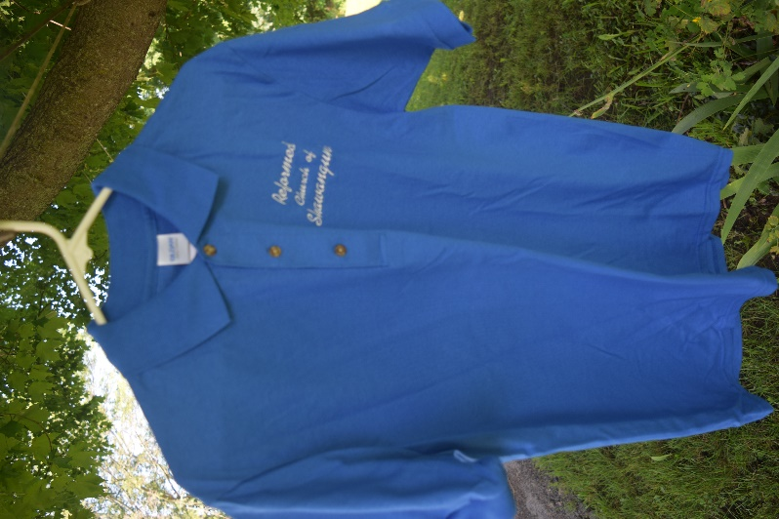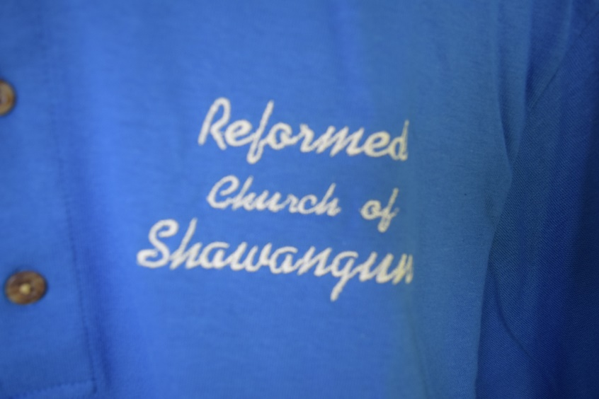
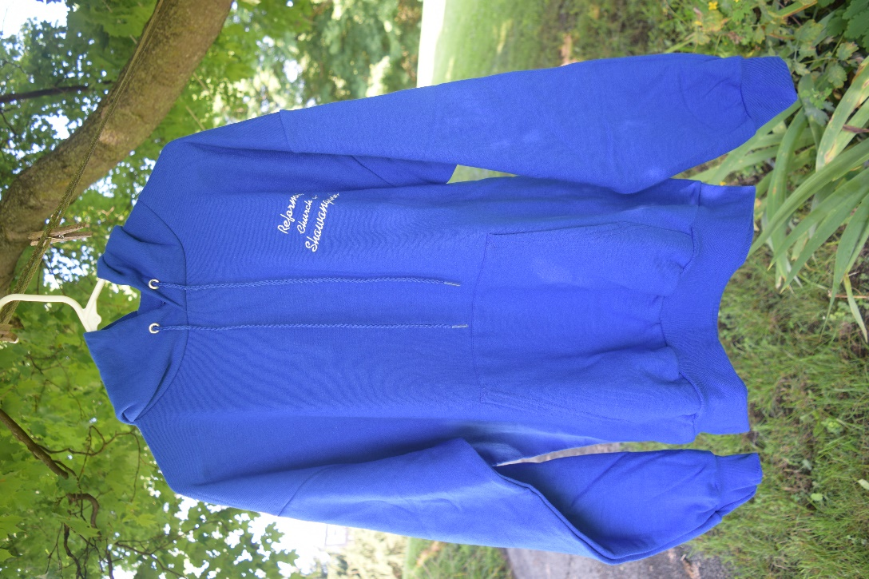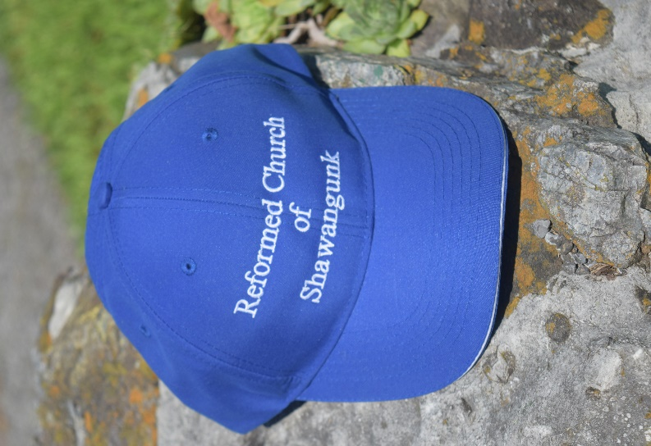
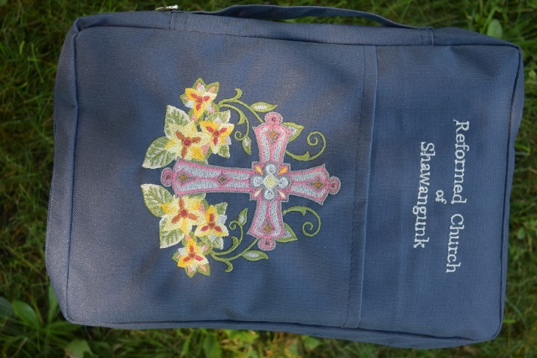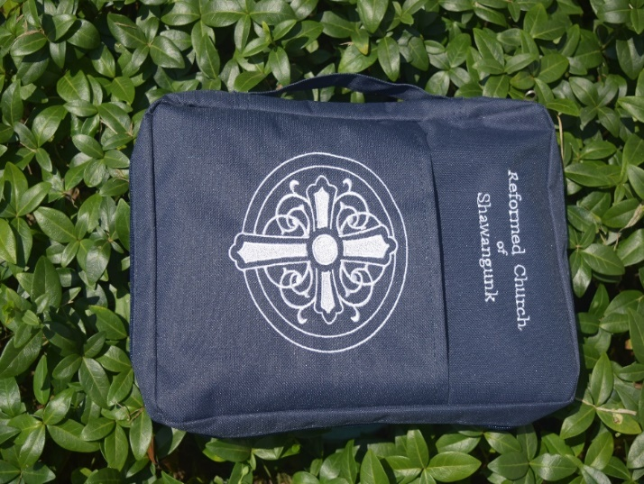
- Cross w/Lily B. White Cross

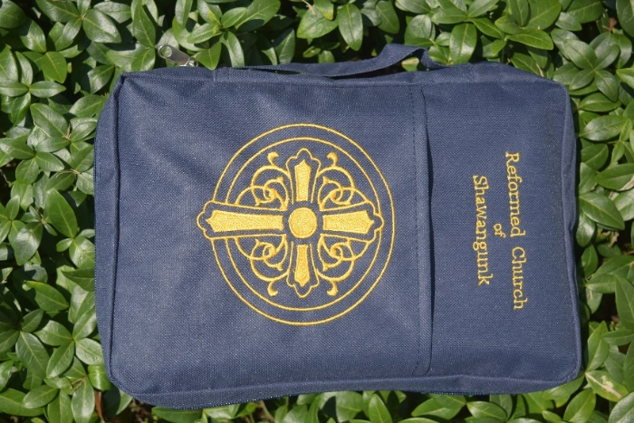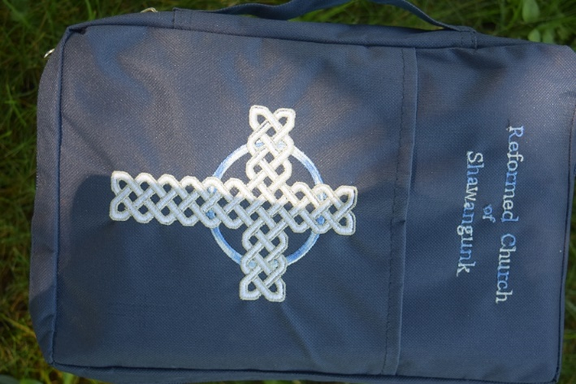
C. Gold Cross D. White Celtic w/ Blue Variegated
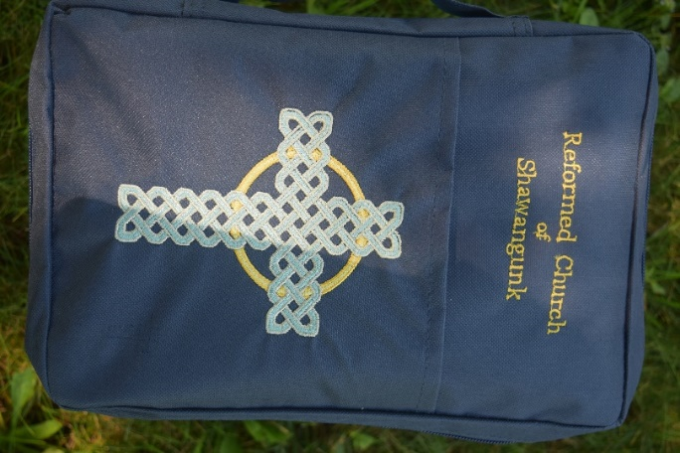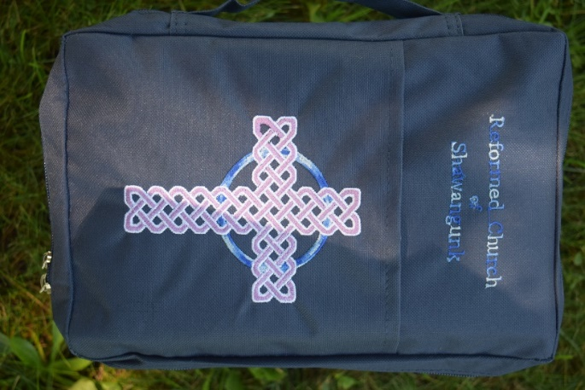
E. Teal Celtic w/ Gold F. Lavender Celtic w/ Blue Variegated
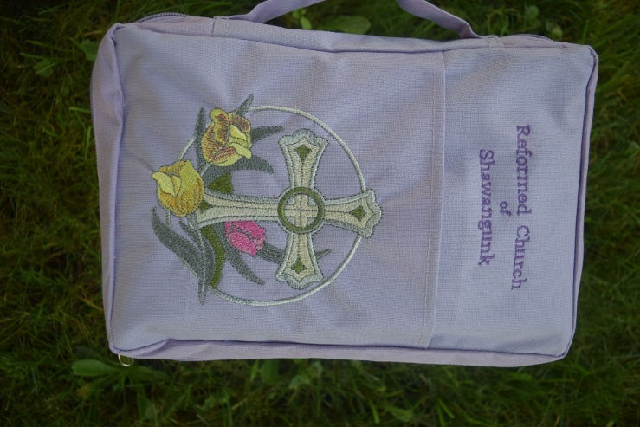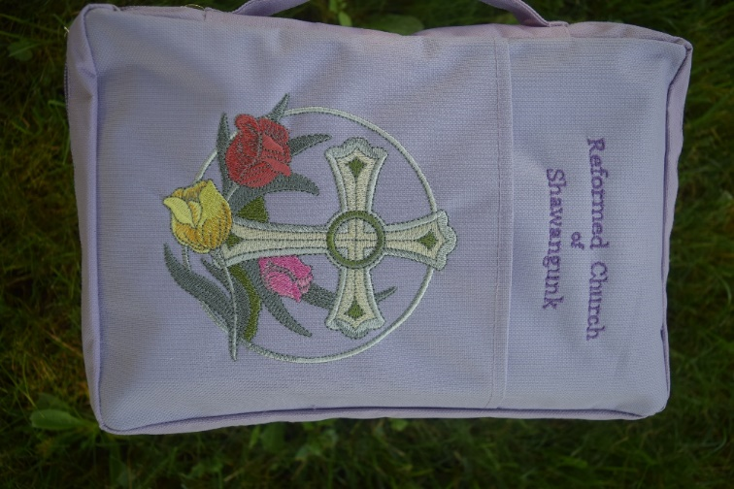
G. Cross w/Tulips H.. Cross w/Tri-Tulips

Canvas Bible Covers - features include convenient spine handle and wrap-around double zipper closure. Handy outside slip pocket. Fits Bibles up to 7.5" x 11" x 1.75".

ORDER FORM

Adjustable Ball Caps $25 each __________
Bible Covers $25 each or 2 for $40 Style # _____________
Adult Unisex 100 % Cotton Jersey Polo $20 each or 2 for $30
Medium _____ Large _____ X-Large ____
Adult Unisex 50/50 Pullover Hoodie $30 each or 2 for $50
Large ___________ X-Large __________

You may customize the polos or hoodies by adding your name or favorite scripture verse (ex. John 3:16) for an additional $5/per item.

Name: _____________________________________________
E-Mail: _____________________________________________
Phone #: ___________________________________________
Total Amount: _______________________________________
(Please make checks payable to Reformed Church of Shawangunk)

